Upload Project lên GitHub

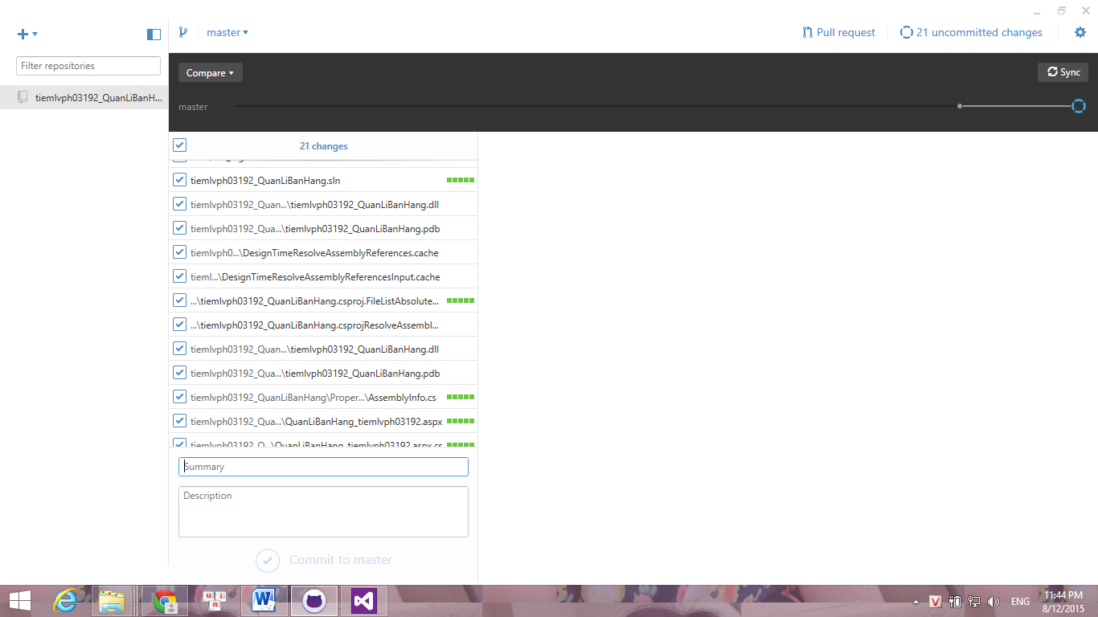

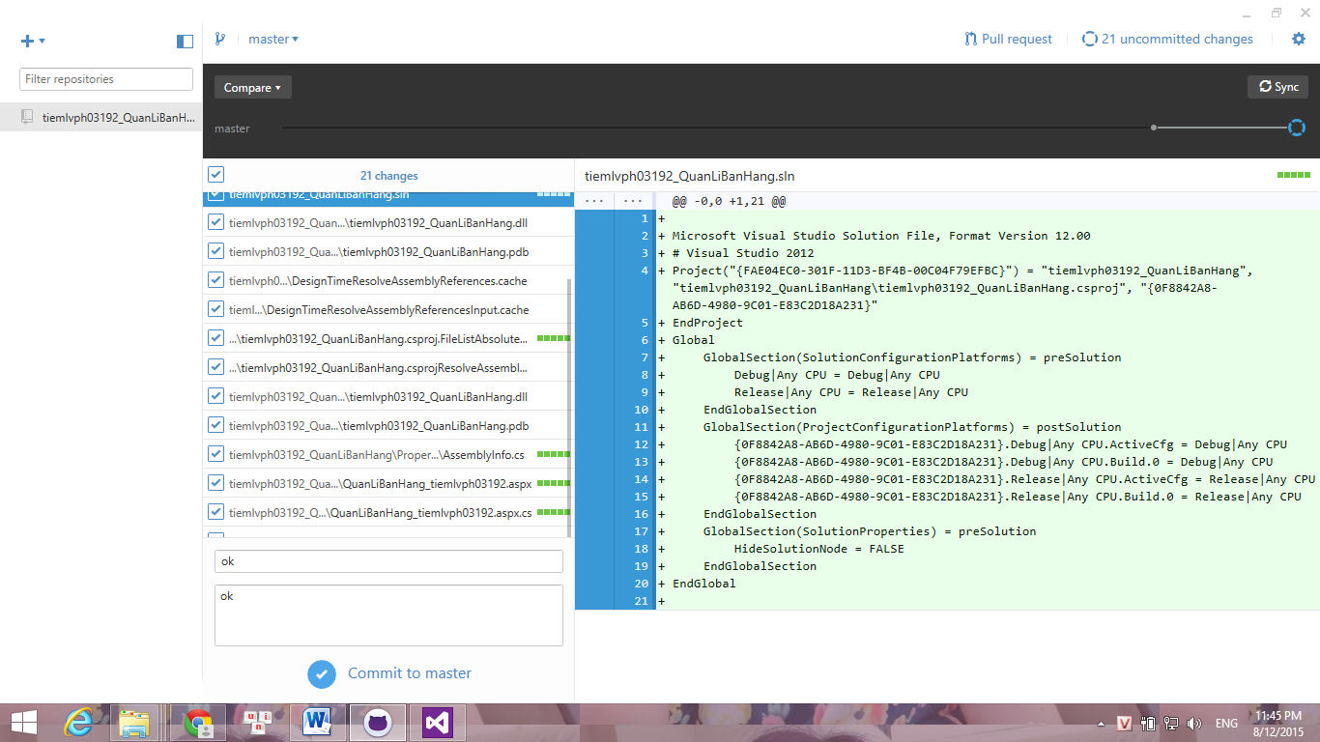

Sau khi upload lên GitHub thành công

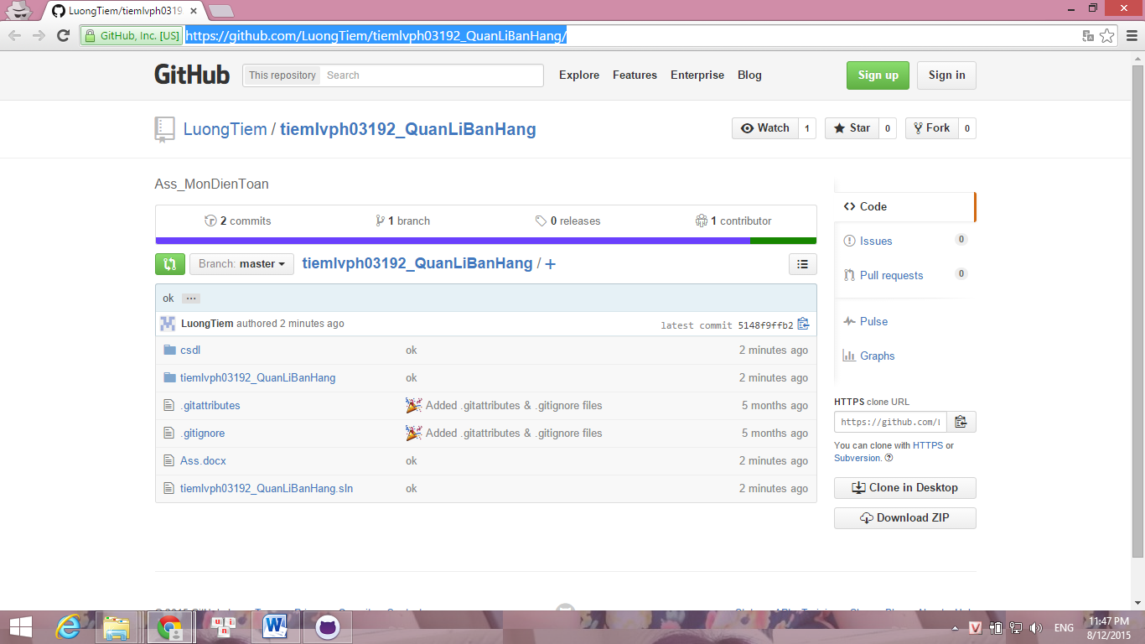

Link github : https://github.com/LuongTiem/tiemlvph03192_QuanLiBanHang/